**Source Code Management**

**Class #1**

**Git Bash(commands):-**

1. git --version

2. git config --global user.name "pulkit garg"

3. git config --global user.email “pulkitgarg123@gmail.com”

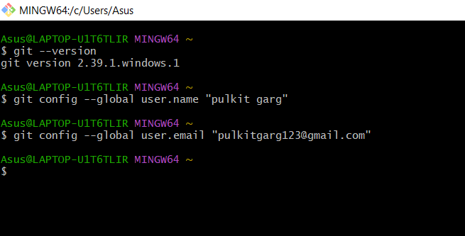

4. make a folder(2210992104) and inside it make one more folder(python code) and right click and open it with git dash and use command git init

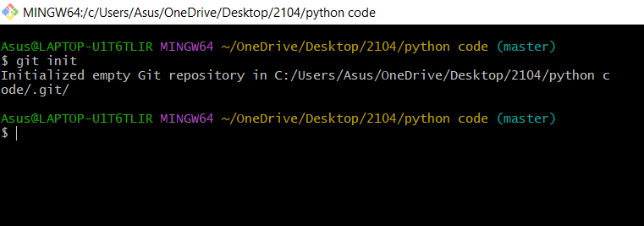 our hidden folder(.git) is produced.

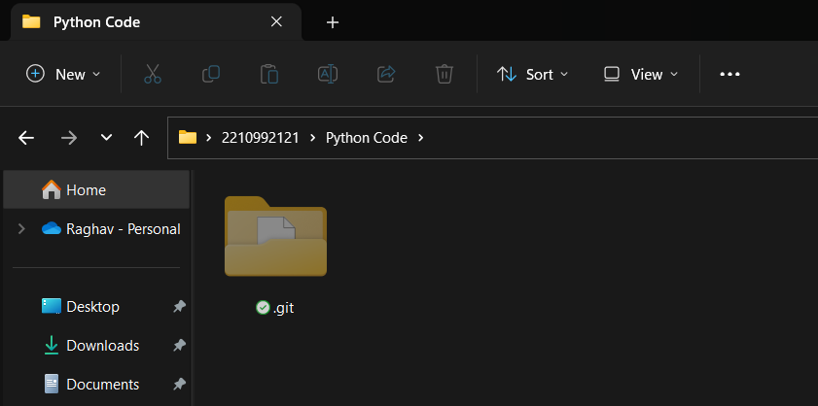

5. git status

6. make one note(Hello) pad inside the folder(python code). use command git add filename.txt

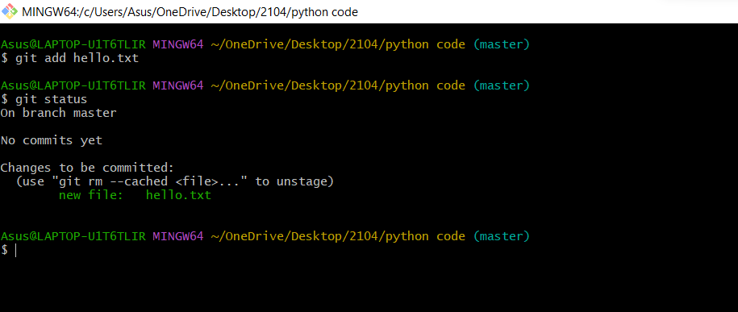

**Class #2**

Terms important for git dash:-

1. Encryption:- Encryption is the method by which information is converted into secret code that hides information's true meaning....

2. Decryption:- to change electronic information or signals that were stored, written, or sent in the form of a secret code back into a form that you can understand and use normally....

3. Hashing:- Hashing is the process of transforming any given key or a string of characters into another value....

4. Digital Signature :- A digital signature is an electronic, encrypted, stamp of authentication on digital information such as email messages, macros, or electronic documents....

5. Public Key:- a public key is a large numerical value that is used to encrypt data

6. Private Key:- The secret part of an asymmetric key pair that is typically used to digitally sign or decrypt data.

**Making a private key in git bash:-**

Make a new notepad

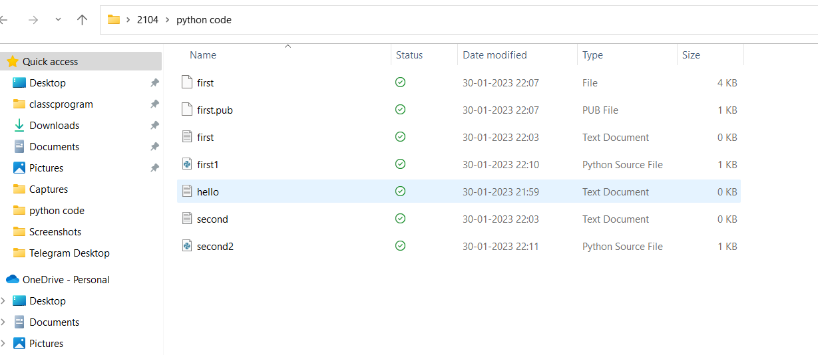

$ssh-keygen -t rsa -b 4096 -C "pulkitgarg123@gmail.com"

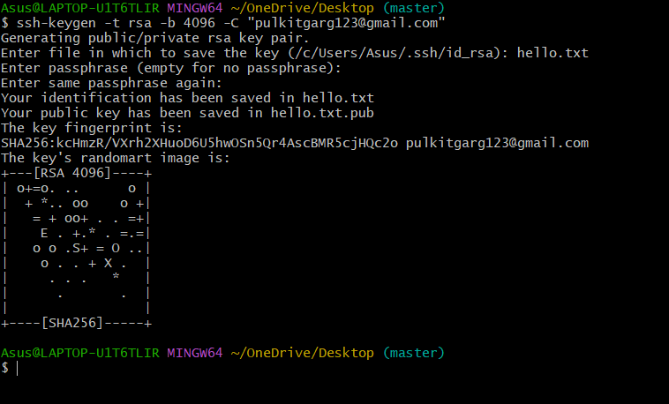

**CLASS #3**

1. Make 2 files as python files in the python code folder..



1. Use command git init.

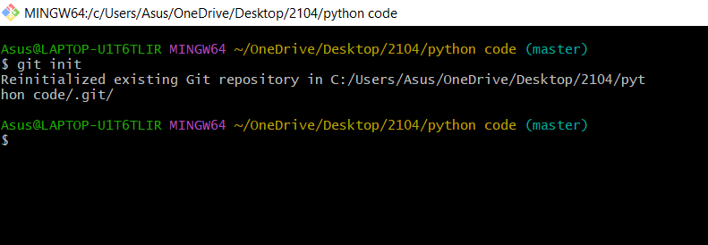

3. git add first.py

4. git status

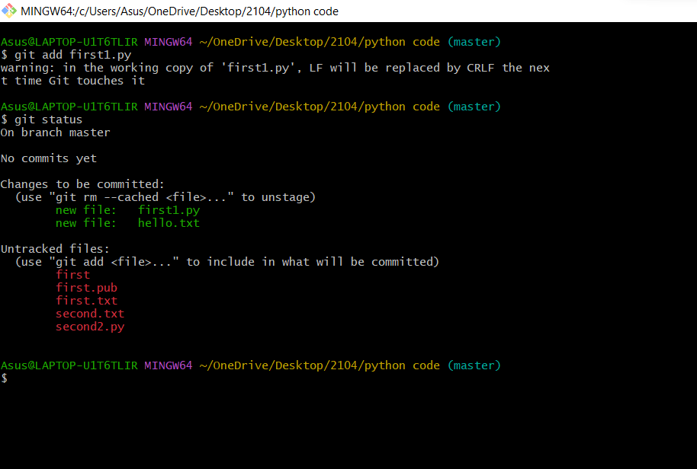

5. git commit -m "First Commit"

6. git status

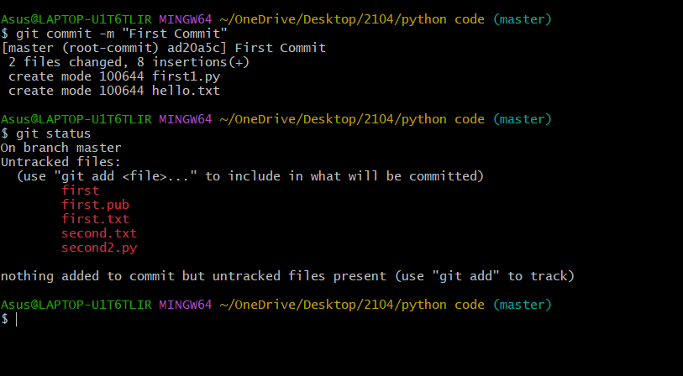

7. git add second.py

8. git status

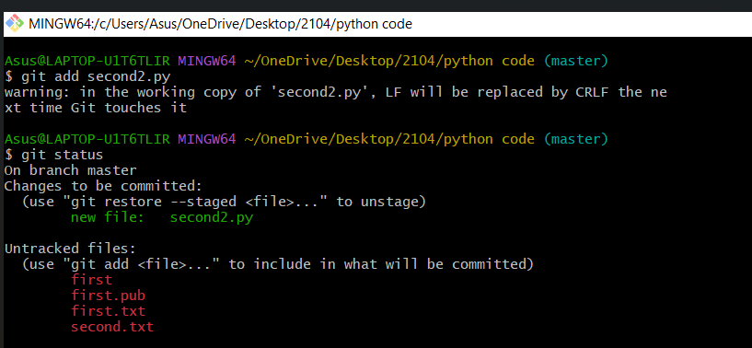

9. git commit -m "second Commit"

10. git status

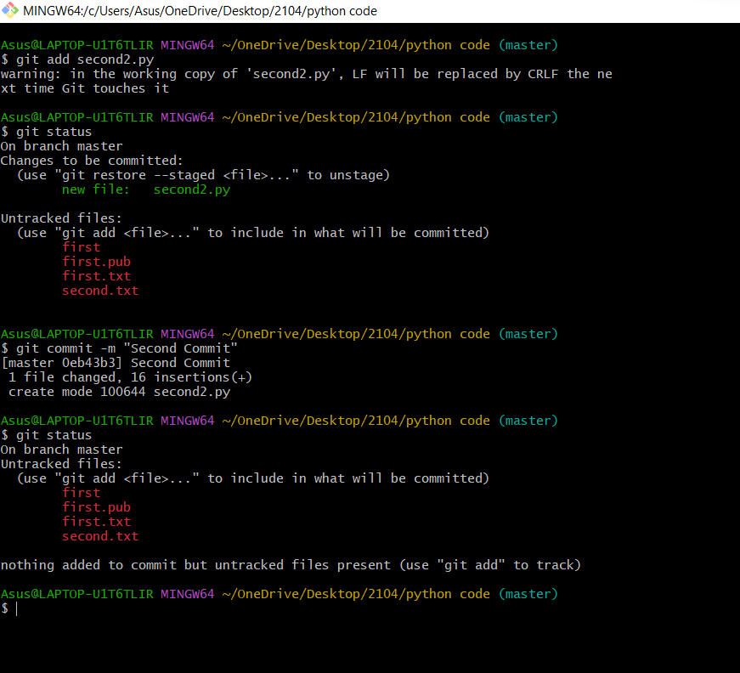

11. In first python file add a print command.(Print("hello))....

12. git commit -m "third commit"

13. git log

14. Use first two digits of commits and go in .git folder and check whether it is present or not.

15. use command:- dir (Directory)

16. use command(in windows git bash):- ls (list)

17. use command in folder's git bash:- mkdir scm (mkdir is used to make directory)

18. dir

19. use cd scm (cd:- change directory)

20. cd .. (to exit folder)